All Russian
Shinkyokushinkai tournament in memory of Andrey Materov.
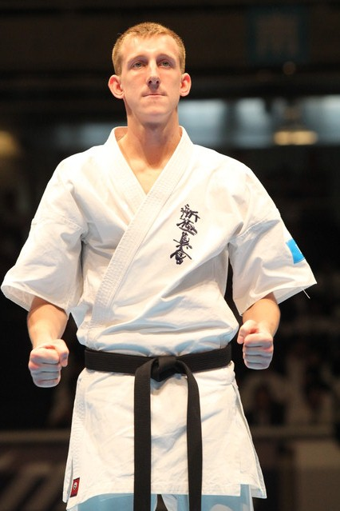

Central Siberia Branch
Branch-chief
Sensei Zakhir Nasirov, 4 Dan
660077, Russia, Krasnoyarsk, Vesny street, 9A.
Phone/fax: +7 (391) 255-90-13
Mobile: +7-913-533-7361
wayoyama@mail.ru
www.wayoyama.ru

- Outline of the Tournament
Name: All Russian Shinkyokushinkai tournament in memory of Andrey Materov (WKO)
Date: March, 15 (Saturday), 2014
Venue: Sport Palace named Ivan Yarygin (Island of Rest, 12, Krasnoyarsk, Russia)
Official Hotel: Hilton Garden Inn Krasnoyarsk (Molokova Street, 37, Krasnoyarsk, 660135, Russia) Application Form №1 (send by e-mail)

Organizer: Organizing Committee of All Russian Shinkyokushinkai tournament in memory of Andrey Materov, NPO World Karate Organization Shinkyokushinkai Central Siberia Branch.

Fighters: men and women from different regions and organizations.
Tournament Style: Full Contact Karate tournament in weight categories.
Awards: 1st – 3rd place of each category (Cup, medal, certificate and additional prize), also Best Technique prize (Ladies and Men), Best Spirit (Ladies and Men).

Friday 14th | 16:00–18:00 weight control/registration time:  WayOyama Dojo, Vesny street, 9A.
 | 18.00-19.00 – filling tournament draw
 | 19.00-20.00 – referee-meeting time
Saturday 15th | 08.00 – opening Sport Palace named Ivan Yarygin
 | 09.00 – competition start
 | 09:00–13:45 – elimination
 | 14:00–Opening ceremony
 | 15:00–16:00 – quarterfinal, semifinal
 | 16:00–17:00 – final bouts
 | 17:30 – Awarding ceremony, closing ceremony
19:00 Sayonara-Party:
The dinner is free for all competitor, referee and VIP.

- Guidance for Application (for Competitors)
Qualified Fighters: Men and Women selected by each region. The competitor should be age 18 years or older on tournament day, have been training Karate, and physically fit enough to fight. Those who are pregnant at the time of the tournament will not be allowed to participate.
Tournament Rules: Full Contact Karate, based on the WKO Competition Rules.
Weight category: Men (-70 kg, -80 kg, +80 kg), Women (-55 kg, -65 kg, +65 kg).

Kumite – Time of Bout
【Male】
 | Main Bout | Extension | The 2nd  Extension | Decision by  Weight | Final  Extension
Elimination | 2 minutes | 2 minutes | 2 minutes | One with lighter weight shall win.  (Valid difference is 5 kilograms in -70 kg., -80 kg, and 10 kilograms in +80 kg.) | 2 minutes
Main Bout | 3 minutes | 2 minutes | 2 minutes | One with lighter weight shall win.  (Valid difference is 5 kilograms in -70 kg., -80 kg, and 10 kilograms in +80 kg.) | 2 minutes

【Female】
 | Main Bout | Extension | The 2nd  Extension | Decision by  Weight | Final  Extension
Elimination  & Main Bout | 2 minutes | 2 minutes | 2 minutes | One with lighter weight shall win.  (Valid difference is 3 kilograms in -55 kg., -65 kg,  and 5 kilograms in +65 kg.) | 2 minutes

Protection
Men: groin protection only.
Women: breast protection (must be the cup type), shin protection.

- Application:
Each Regional Representative is requested to inform the Central Siberia Branch office of their fighter(s) before deadline of the Application. Each competitor has to submit the following documents through their affiliated Country/Regional Representative or Branch Chief/Contact:
Application Form №2 (send by e-mail)
Medical Certificate issued by a doctor (show on weight control/registration)
Deadline of all Application: Must reach the Central Siberia Branch office no later than Thursday, February 20, 2014 (e-mail: wayoyama@mail.ru)

- Visa support
If fighter(s) needs a visa to enter Russia, he/she should fill and send the Application form for
visa support (Visa Questionnaire). Please also send a Passport Copy.
On the following E-mail: wayoyama@mail.ru
Mr. Gennady Nechaev
Tel.: +7-983-269-6823, Fax: +7 (391) 255-90-13

- Hotel Fees
March 14 (Fri) – March 16 (Sun) out, Twin Rooms for 2 nights, with breakfast.
80USD (2.500 rubles) per night for each guest.
2 nights = 160USD (5.000 rubles) for each guest.

Notice for the tournament:
The fighters must wear a clean, white Dogi with calligraphy of their organization. Opening Ceremony: Competitors should dress Dogi.
- Others
Entry fee: free.
Tournament Tickets: free.
Sayonara Party: restaurant «Leili Medjnun», Shakhterov street, 62/1, 2nd floor.
The participants are to arrange their flight/transportation on their own expenses.

Hoping to hear from you, and looking forward to see you, and your fighters
on the 15th of March 2014 in Krasnoyarsk!

